34.69: a) 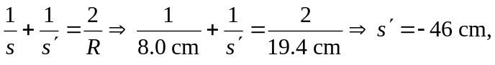 so the image is virtual.
b) 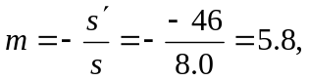 so the image is erect, and its height is:
c) When the filament is 8 cm from the mirror, there is no place where a real image can be formed.

